# Lab0: Be familiar with Ubuntu

Alex Chang last modified on 04/10, 2020.

The objective of the tutorial is to have your working environments: Ubuntu 18.04 system. The content is aimed for beginners who have little knowledge about basic commands in Ubuntu and Vim.

*Any sentence behind “$” means those are commands that typed in the terminal*

*$ 代表terminal的指令*

* *laptop: do the command after $ on the laptop/PC side*
* *laptop: 代表在筆電上打指令*

## Hardware and Software Setup

The tutorial requires Ubuntu 18.04 system installed in the following:

* First option, use the provided Virtualbox ([image](https://drive.google.com/file/d/1Wzun0dhT_JbtxB6XJiNO3a86GygbaYea/view?usp=sharing), 4.6 GB).

**Username/Password** of this ubuntu image: **arg / bocelli2015**

* Second option, use the provided USB Virtualbox image from our Teaching Assistant
* For advanced users who wish to have native system, take a look at our Dockerfiles

**Lab0: Be familiar with Ubuntu** **1**

Hardware and Software Setup 1

Overview 2

Topics and Activities 2

Topic/Activity 1 Ubuntu introduction 2

Topic/Activity 2 Ubuntu Installation 3

Topic/Activity 3 Use Ubuntu and Vim 8

Exercise 1: Change the hostname 9

## 

## Overview

Estimated Time to Finish: 0.5 hours

After completing this tutorial you should

* understand how to install ubuntu system on your laptop
* be able to use vim to modify the text file
* develop the common sense of ubuntu system

## Topics and Activities

### Topic/Activity 1 Ubuntu introduction

**Why to use Ubuntu Linux for this course?**

* It’s convenient to install the software, just type the cammands like   
  “sudo apt-get install [PACKAGE1] [PACKAGE2]”

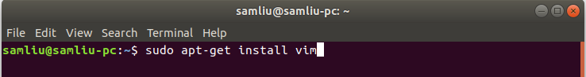

* Supporting all functionaries of ROS (Robotic operating system) and RVIZ (a visualization tool for ROS) that allow we to develop most of applications for the robot.

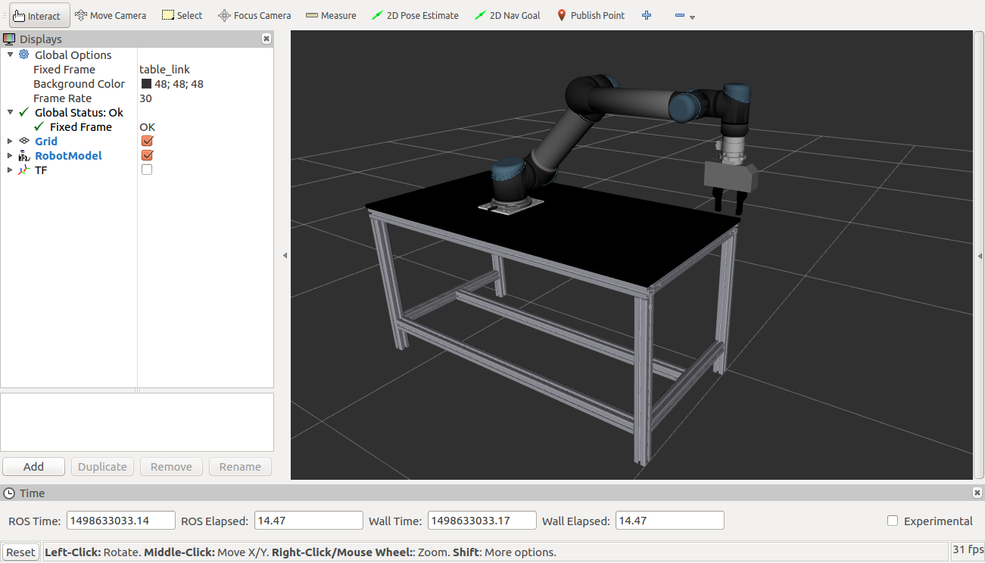

* Most of the deep learning frameworks are support the Ubuntu environment, such as Caffe, Tensorflow and Pytorch.

 

### Topic/Activity 2 Ubuntu Installation

**Download and install Virtualbox on your machine**

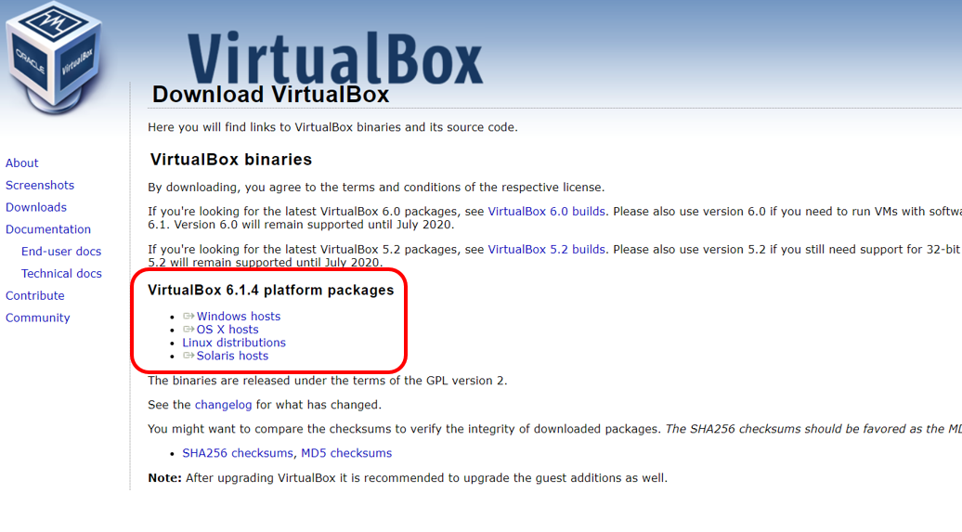

**[Please choose the latest version of virtualbox and ignore the older one shown in above figure.]**

<https://www.virtualbox.org/wiki/Downloads>

**Start Virtualbox**

New(新增) -> Linux -> 64bit -> Memory 2048M -> select the .vdi file.

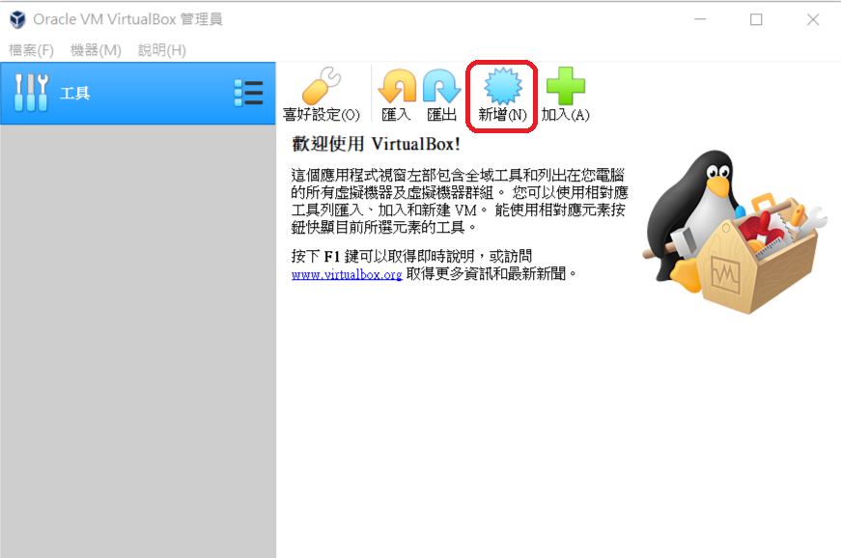

Give a name to this virtual machine as you want.

|  |  |
| --- | --- |
|  |  |

To use the existing VirtualBox image, please assign the correct path to the VirtualBox image file (**.vdi** extension) downloaded from here.

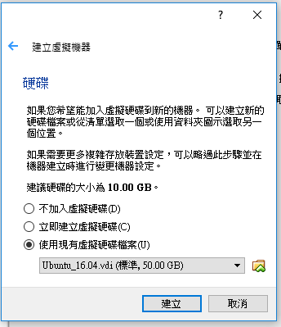

Press the “activate” to activate your virtual machine.

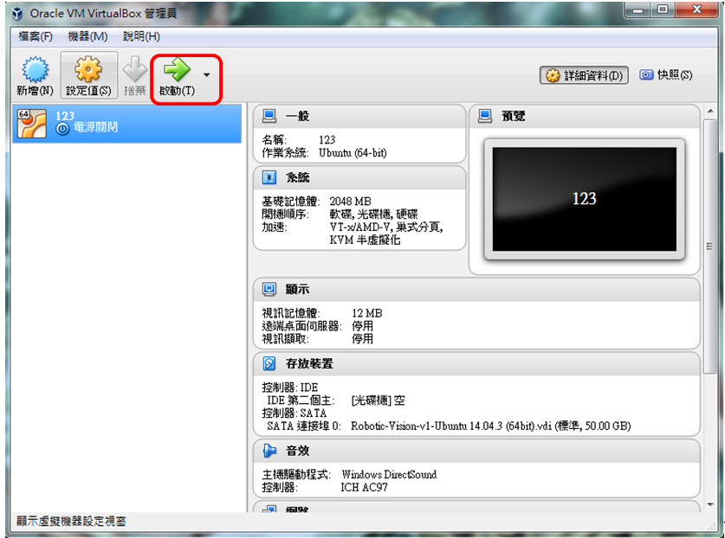

The username/password are **arg / bocelli2015**

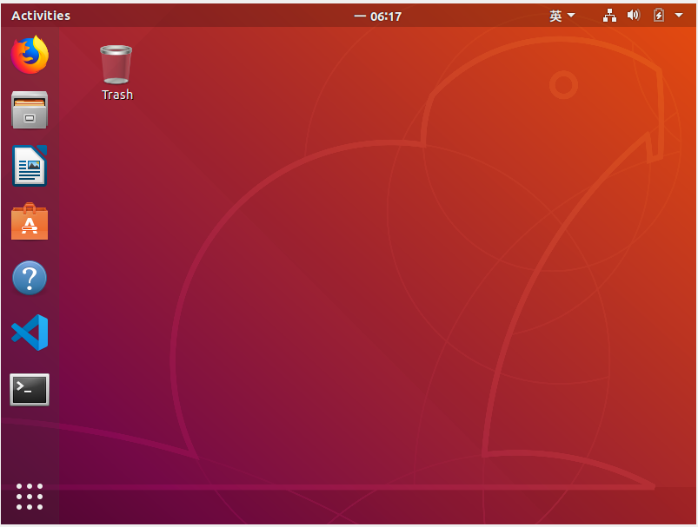

**Network Setup**

Open the setting terminal from 裝置 -> 網路 -> 網路設定

Change the ‘attaching interface’ to bridged adapter (橋接介面卡). If you are using Wi-Fi interface on host OS, please choose the Wi-Fi chip module. The keywords often appearing in the drop-down menu are 'Realtek’, ‘88XX’ and ‘wireless’. If you are using Ethernet, please choose ‘PCIe GBE Family Controller’.

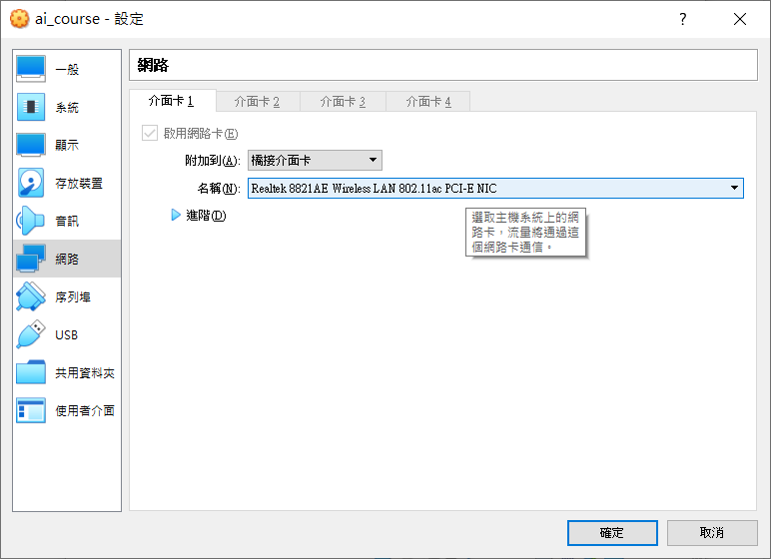

**Scrapbook Setup**

共用剪貼簿

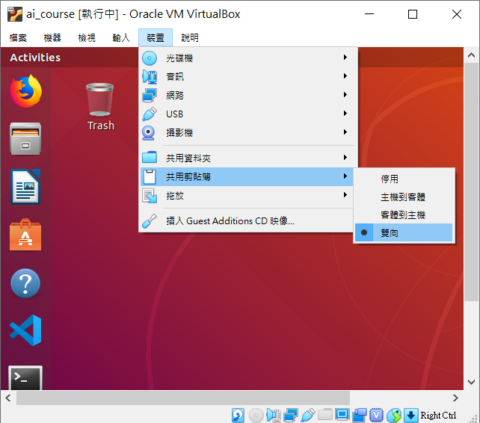

**Drag and Drop**

托放

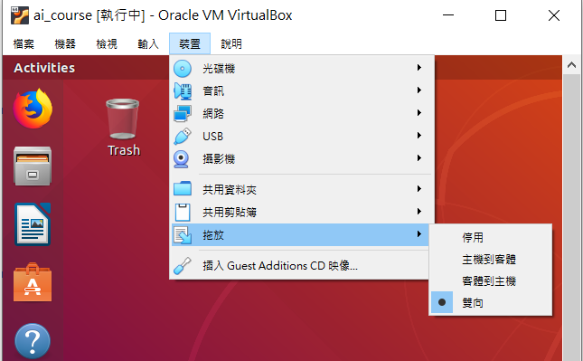

### 

### Topic/Activity 3 Use Ubuntu and Vim

Most tasks can be complete in Terminal for Ubuntu OS. We list the **famous shortcut** and **basic terminal commands** you should know in the Ubuntu Linux.

|  |  |
| --- | --- |
| **Ctrl + Alt + T** | Open a new Terminal window. |
| **Ctrl + Shift + T** | Open a new Terminal tab. (if terminal window existing) |
| **Ctrl + Shift + C** | Copy text from the current terminal. (if you have selected something in terminal) |
| **Ctrl + Shift + V** | Paste something from scrapbook to the current terminal. |
| **Ctrl + L** | Clean the current terminal |

|  |  |
| --- | --- |
| **sudo** [COMMAND] | act as root before other commands (**最高權限進行指令**) |
| **cd** [directory] | enter a folder (**進入資料夾**) |
| **ls** | list all files and folders in current directory(**列出該目錄所有檔案、資料夾**) |
| **mkdir** [dir name] | create a folder (**建立新資料夾**) |
| **cp** [file] [new file] | copy files **(複製檔案)** |
| **rm** [file] | delete files **(刪除檔案)** |
| **apt-get update** | update packages **(取得遠端更新伺服器的套件檔案清單)** |
| **apt-get instal**l [package name] | install packages **(安裝套件)** |
| **git clone** [url of remote repository] | Git command line utility which is used to target an existing repository and create a clone, or copy of the target repository. **(透過Git系統從遠端repo複製一份repo到本地端)** |
| [COMMAND1] **&&** [COMMAND2] | **(做完COMMAND1 後 做COMMAND2)** |
| **sudo shutdown now** |  |
| **sudo reboot** |  |

#### Exercise 1: Change the hostname

HOSTNAME represents a machine name that helps other computers or laptops identify with your machine. Due to our fleet setting, we wish that all laptops have unique hostname. We suggest to use:

* [Name] for your laptop, ex: allen

**在更改筆電的hostname時，請不要使用特殊字元 (e.g. %^#@!_,;:” )，只用數字以及小寫英文字母**

Open a terminal (press this terminal app shown below or type [**ctrl + alt + T**]):

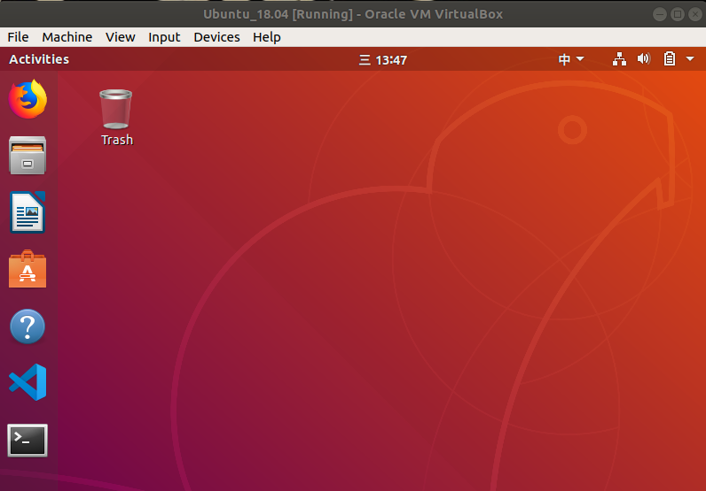

type in the command below:

記得打sudo, 沒有sudo會無法更改此檔案

**laptop$ sudo vim /etc/hostname**

[sudo] password for arg: bocelli2015

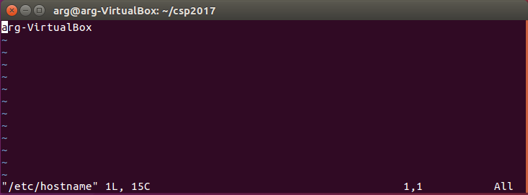

若不小心忘了打sudo卻已經更改檔案，請打”**:q!**”強制退出後再加上sudo進去一次

Change "hostname" to your own hostname. For example: alex

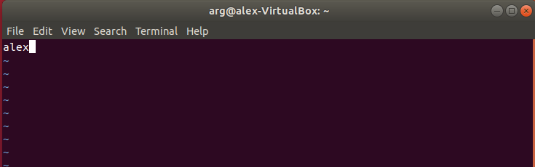

For information about vim & how to use it,

check<http://linux.vbird.org/linux_basic/0310vi.php>

[After exiting vim editing and go back to terminal, type in the command below:](http://linux.vbird.org/linux_basic/0310vi.php)

記得打sudo, 若沒有sudo會沒有權限 (Permission deny)更改此檔案

**laptop$ sudo vim /etc/hosts**

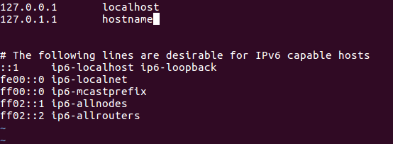

change "hostname" to the one you typed in the /etc/hostname file, don’t forget to save it (:wq) after modification.

將hostname改的跟剛剛在/etc/hostname一樣的名字，並儲存

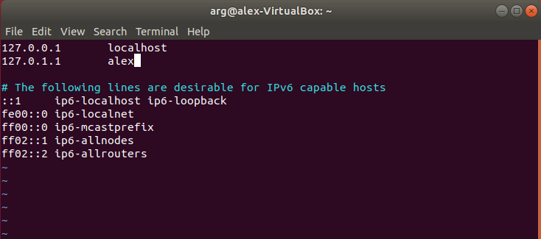

Then reboot (重開機)

**laptop $ sudo reboot**

Double check if hostname is changed.

確認hostname改變了

